|  |
| --- |
| team |
| +Name string  +Home Location string  +Division String  +ChampHostSelection bool // one for dive and one for swim  +AllStarSelection bool  +IsPlaying bool |
| +Add Team void  +Remove Team bool // changes is playing |

|  |
| --- |
| Meet Generator |
| + Existing data from previous meets; file |
| +TriMeetPicker void //there will statistically be a try meet every week, needs to be able to be turned off if there is an even number of teams   * Division Meet Generator void// picks swim meets first * Start and end of season void |

Misc functions

* Save
* Exceptions menu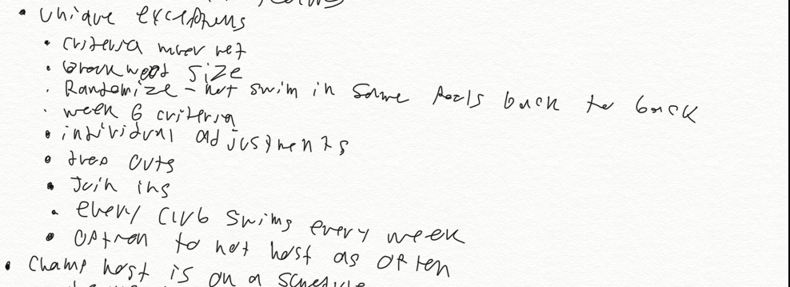
* Undo
* Change after auto generate
* Save and load date form a non local storage device
* Identifiers for each division next to name
* Export options
  + excel
  + to flash drive